Ollscoil na hÉireann, Corcaigh

National University of Ireland, Cork



Assignment 1

By

Karl Russel Concha, 122317446

IS2209

01/04/2024

MODULE LECTURER: SIMON WOODWORTH

Word count: --

I have read the University College Cork’s Policy on Plagiarism, and I declare that the content of this assignment is all my own work. Where the work of others has been used to augment my assignment, it has been referenced in accordance with academic convention.

This assignment complies with the UCC requirements and guidelines on plagiarism:

YES NO



(Please tick ✓ **one** box.)

Karl Russel Concha

**Signed** . . . . . . . . . . . . . . . . . . . . . . . . . . . . . . .

*For hard copy submissions, use a handwritten signature. Typed names ONLY accepted for online submissions*

# IS2209 AssDignment 1 Report

## Setup Instructions

1. Download the project folder. Open the project folder using an IDE (Vscode is used in the example.)
2. Select ‘app.py’. To run the app, click on the run button.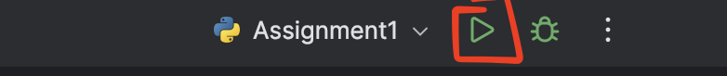
3. Click (or CMD click) the http link given. 
4. A homepage will appear as seen below. This is the main hub for the website posts. Clicking ‘Board’ will redirect the user to the homepage.

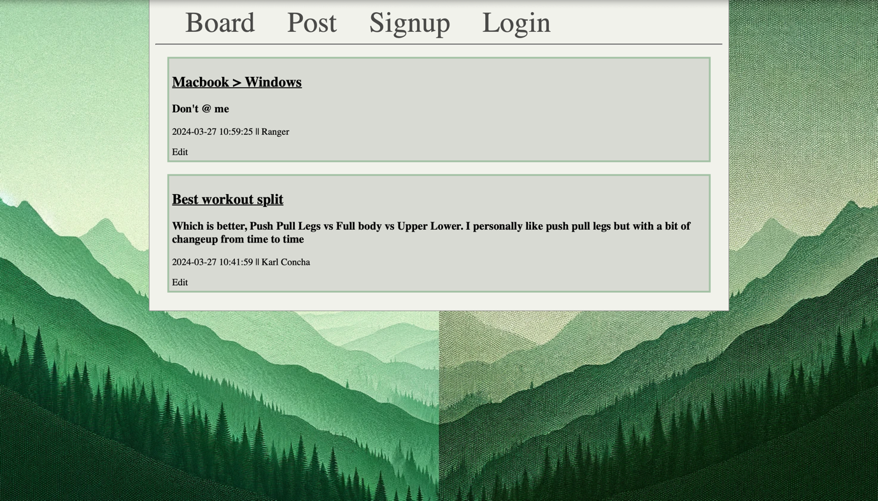

### Signing up / Logging in

1. Before the user can post or reply to a message, they first must login or sign up if they have no account. (If the user already has an account skip to step 4.)
2. Clicking ‘Signup’ will redirect you the signup page.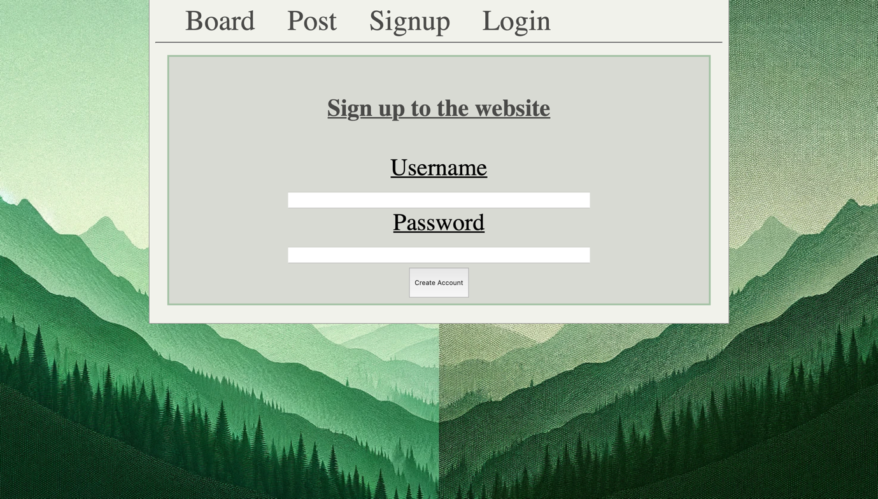
3. Input a username you desire and a secure password and click ‘Create Account’.
4. You / the user will be redirected back to the homepage. Click ‘Login’ to sign in. 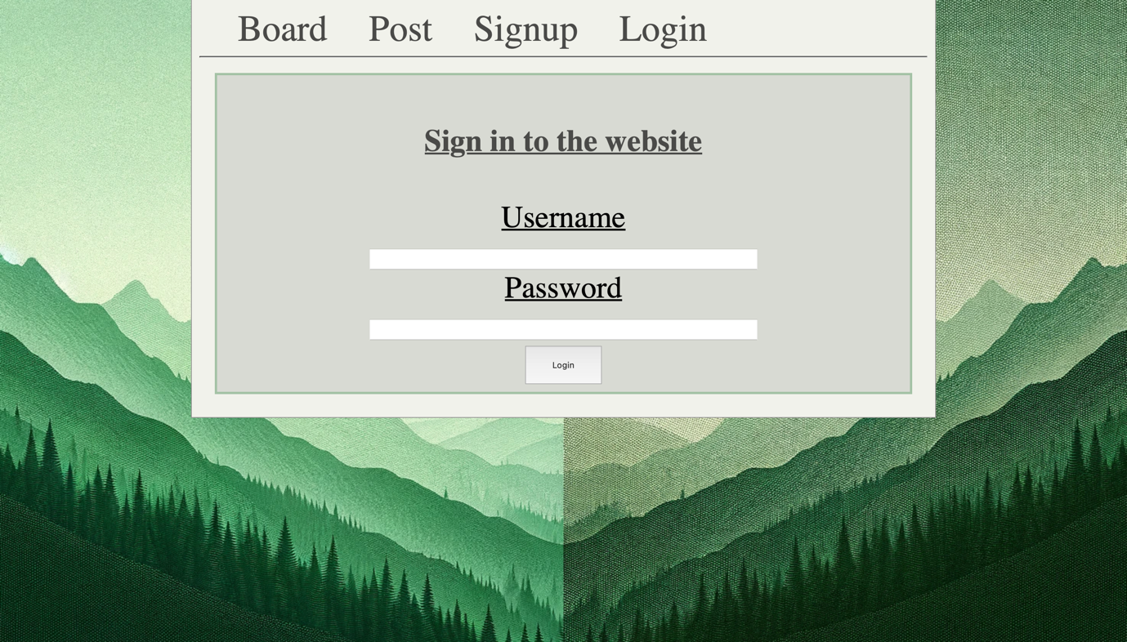
5. After logging in. The username will appear between ‘Signup’ and ‘Logout’. Now you can post and reply to messages. Click ‘Logout’ to sign out. 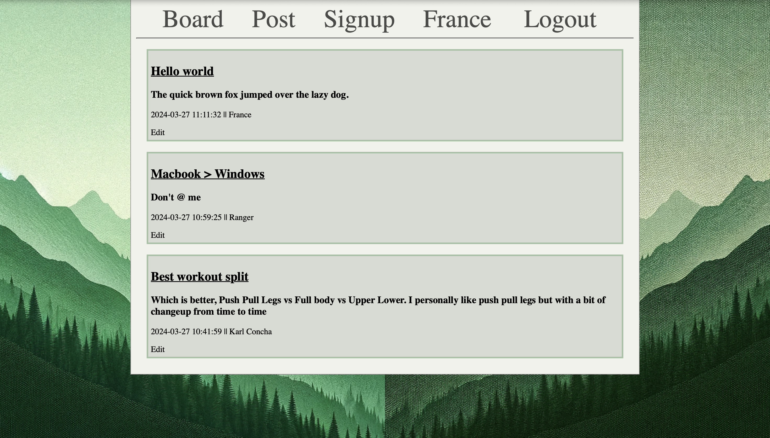

##### Premade Accounts:

* **Account 1:**
  + Username – France
  + Password – 456
* **Account 2:**
  + Username – Ranger
  + Password – 789
* **Account 3:** 
  + Username – Karl Concha
  + Password – 123

### Posting a message

1. Click ‘Post’. This will redirect you to creating your own message.
2. Fill all the fields needed and click ‘post’ (not doing so will flash an invalid message). 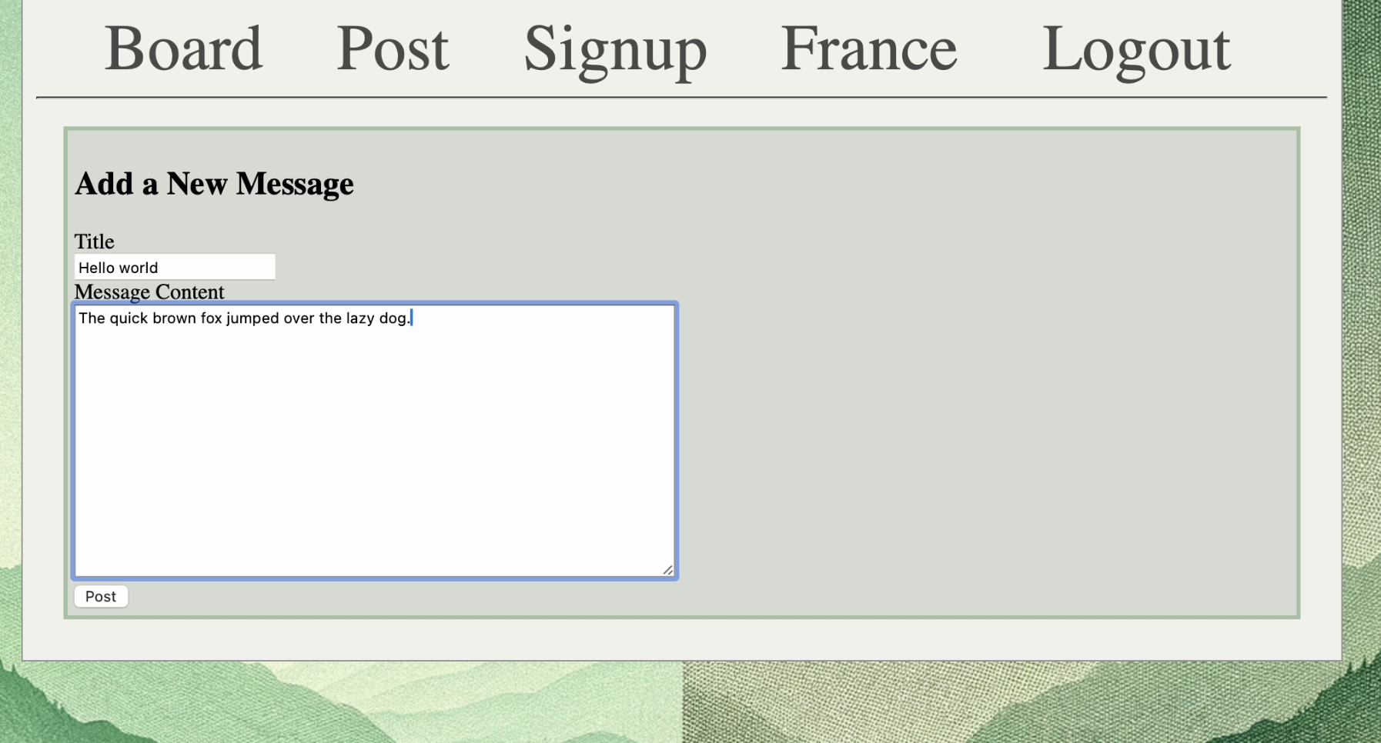
3. You will be redirected back to the homepage with your message appearing on the top of the board.

### Editing / Deleting a post

1. Make sure to be logged in before editing your message.
2. Click ‘Edit’ located at the bottom of your post.
3. Change the fields wanted and click ‘Submit’. This will save the edited message. 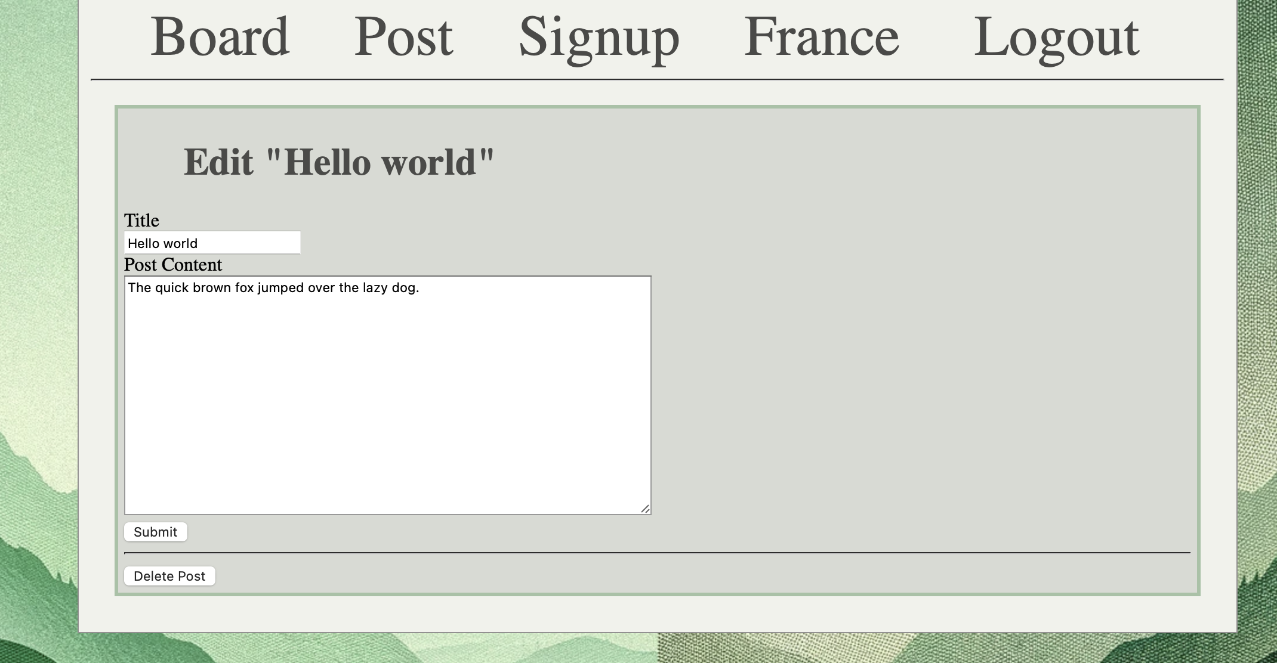
4. If you want to delete, click ‘Delete’ and confirm by clicking ‘ok’. 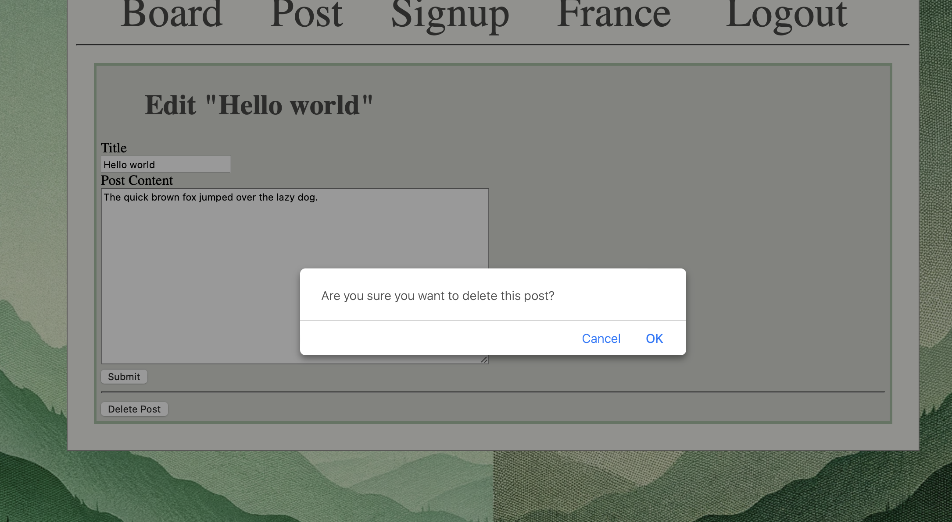

### Replying to a post

1. If you want to reply to another user’s (or your) post, Click on the underlined title of the desired post.
2. This will bring you to a focused view of the post with their replies. 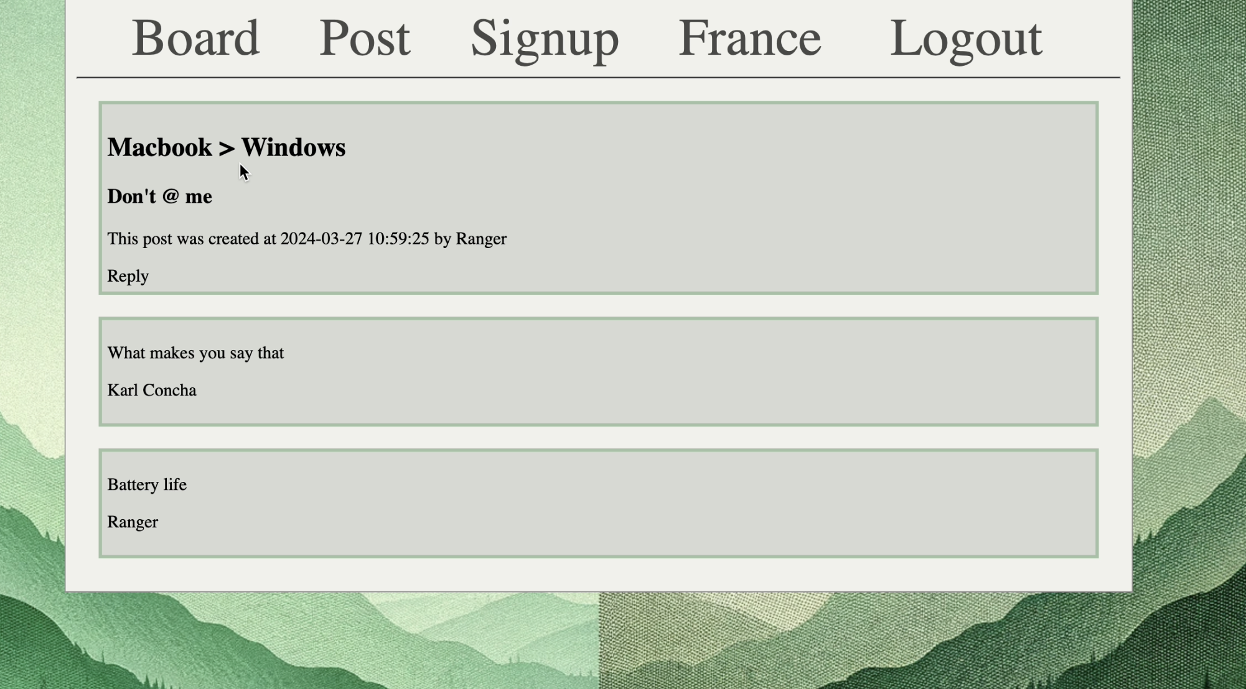
3. Click ‘Reply’ and fill in the needed fields. Click ‘Reply’ and your message will appear at the bottom of the tree. 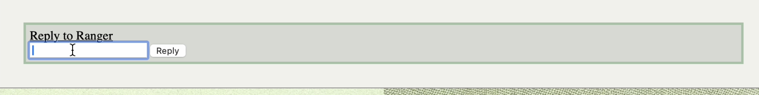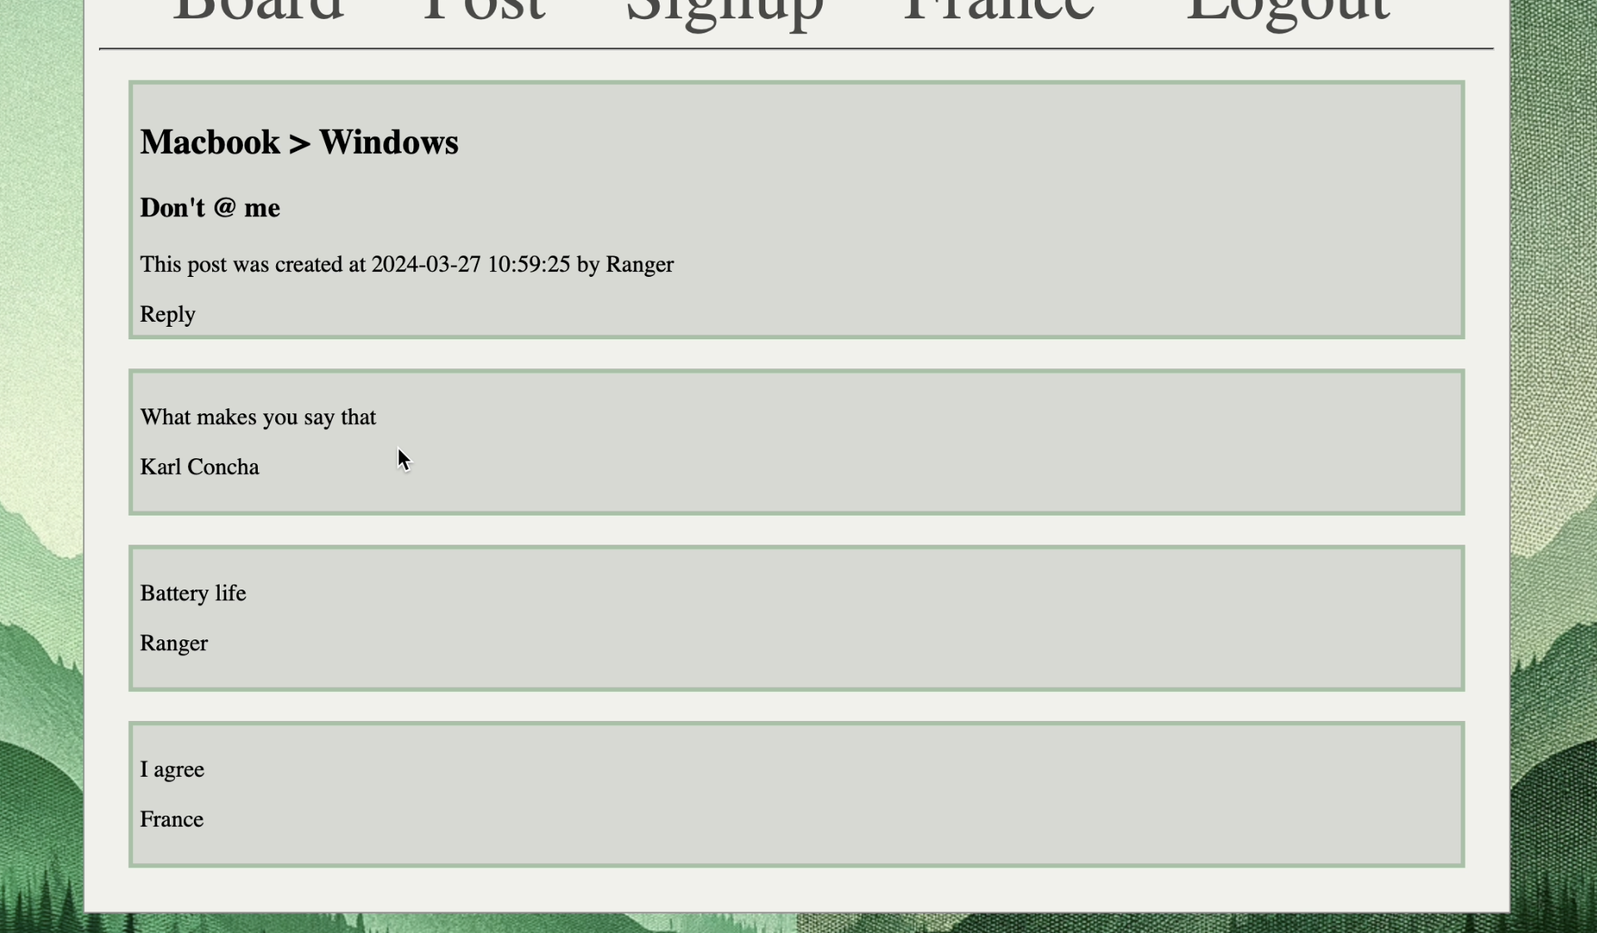

## Design Decisions

### Colours

Before tackling the assignment, I needed a set of colours for the website. Using the website *‘coolors.co’* (coolors, 2024), a colour palette was given to me that I like and is visually appealing (shown below). The different shades of green emit a relaxing or cosy visual. Additionally, there is a dark and white colour to help with texturing the background and texts.

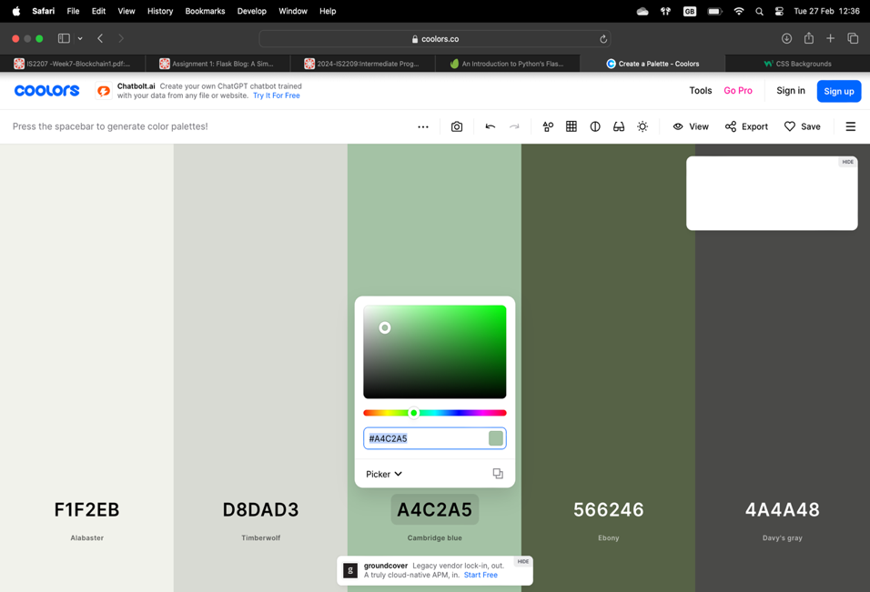

Figure 1. The chosen colour palette

### Functionality

Inspired by the website ‘*https://www.e46fanatics.com’* (Fanatics, 2024), I wanted to create a function where a user can post for a question or fun and get responses relating to the post subject. The website ‘e46fanatics.com’ is a community of BMW E46 car owners, soon to be, and / or users who are just interested. This sense of user to user communication was lacking in my website.

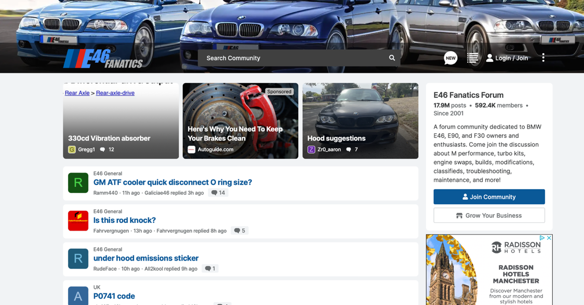

Figure 2. e46fanatics homepage

I had to decide whether my website would house many different subjects or would be a specific type of chat website. I decided to keep it broad and choose the first option. Keeping the website chat to a specific topic would mean needing proof that this website is only for that (having relating guides, pictures, and domain name).

### Website Layout

The general layout is taken from the *digital ocean tutorials* (Ocean, 2024). I modified the colours and layout to match what I want the page to look like.

I wanted to add a background image behind the main content. I felt the website was too wide for its minimal usage. The only tasks the user needs to do is sign-up, sign-in, configure a message, and delete a post. When involving pictures or videos, that is when I feel using the whole page would be incredibly beneficial.

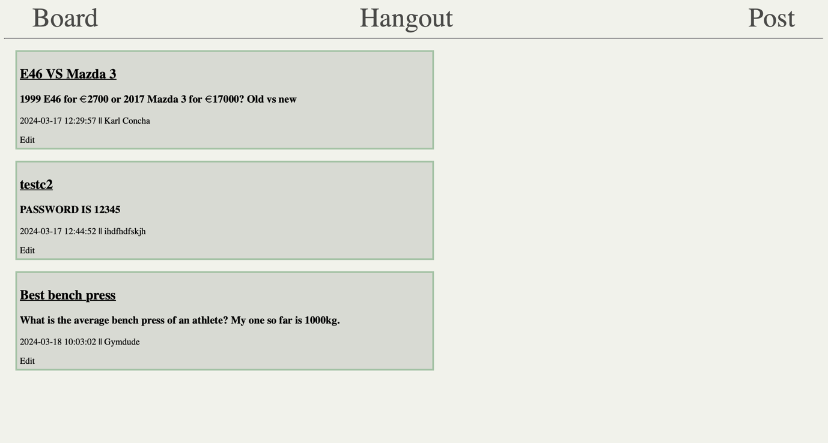

Figure 3. The old layout of the webpage

With the new design layout, all the content feels more contained. There’s no feeling of wasted space as last time. The matching background (*generated by Dall-E* (Chat-GPT, 2024)*)* with the colour palette helps the website visually.



Figure 4. The improved and current layout

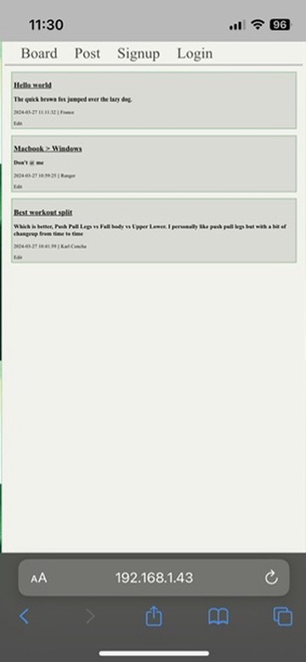

Figure 5.Mobile layout

## Application Structure

### Code quality

The code for the application is structured in a way where there is a clear direction of where the routing is and sectioned into main functions, extra functions, and database fetching. The CRUD operations in the ‘app.py’ is given with a comment to help with solving a problem with the database.

### Problems faced and solutions

##### Adding a user sign-up:

* To prevent random users to edit messages, a sign-up was implemented.
* This stops guest users from only being able to view and needing to login to access the full features.
* A session is implemented to create and keep the authorisation (with the help of a stack overflow post). (Zvone, 2020)

##### User login is saved after logging out:

* When logging in then ending the app, then running again, the previous user login would be still logged in.
* To solve this, instead of a static key, a random key is generated every time instead.
* This fixed the problem as each session is now unique.

##### Adding a reply feature

* Needed to delete the old database. Modified it to add a parent_id and a foreign key relationship with the postid.
* This helped implement the reply feature but added a future possible problem, as the reply and post are mixed.

##### Deleting or modifying a user account

* Was not able to implement this feature.
* The problem was if user did not remember their password, a way was needed to verify them without it.
* Could have been an e-mail or a hint after x amount of tries.
* Did not have enough coding knowledge to solve it.

##### Delete user reply messages

* Did not implement.
* This feature relates to the feature stated above. If a user changes or deletes account, their replies are either modified or deleted.
* Not enough time to add a new form and new route as only thought about it when the code is completed.

### Troubleshooting

Using Vscode, the venv might not have been activated,

To fix:

1. Type *‘source ./.venv/bin/activate’* in the terminal

Using Pycharm, an error might come up shown below,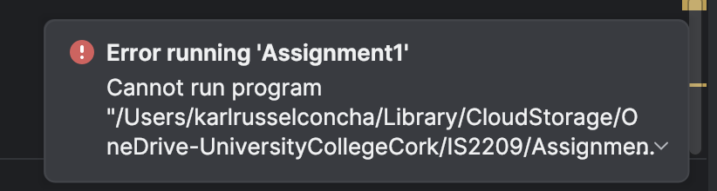

To fix:

1. Click ‘Configure Python Interpreter’
2. Select ‘Interpreter settings’



1. Select ‘Add Local Interpreter’ and Click ‘Existing’ venv. The file path should redirect to the project file venv.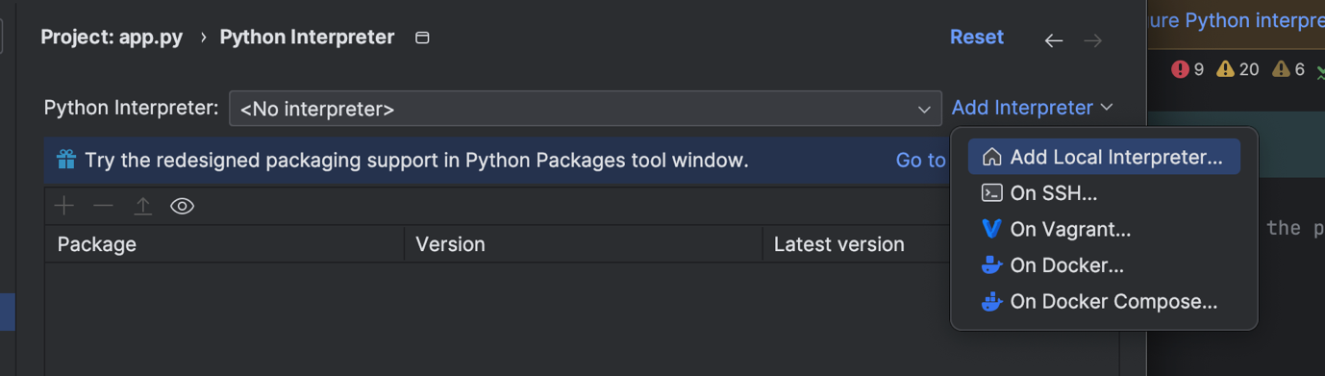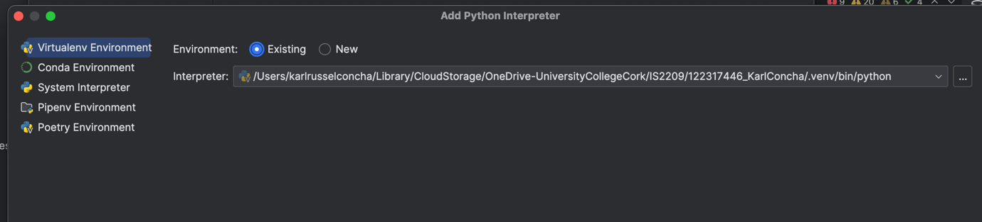

# Bibliography

Chat-GPT. (2024). *ChatGPT*. Retrieved from chat.openai.com

coolors. (2024). *coolors.co*. Retrieved from coolors.co: https://coolors.co

Fanatics, e. (2024). *E46 Fanatics Forum*. Retrieved from E46 Fanatics Forum: https://www.e46fanatics.com

Ocean, D. (2024). *How To Use an SQLite Database in a Flask Application*. Retrieved from digitalocean.com: https://www.digitalocean.com/community/tutorials/how-to-use-an-sqlite-database-in-a-flask-application

Zvone. (2020). *StackOverflow*. Retrieved from StackOverflow: https://stackoverflow.com/questions/62867842/how-does-flask-login-session-works